**Introduction to the US Banking Structure**

The US banking system is a complex and multifaceted industry that plays a crucial role in the country's economy. It is comprised of a diverse array of financial institutions, each with its own unique functions and regulatory oversight. From commercial banks and credit unions to investment firms and fintech companies, the US banking landscape is constantly evolving to meet the ever-changing needs of consumers and businesses alike.

**Descriptive Analytics: Composition of the US Banking Sector**

The US banking sector is incredibly diverse, serving the needs of individuals, businesses, and the broader economy. At its core are commercial banks, which hold the majority of the industry's assets and deposits. These range from large, multinational institutions to small, community-focused lenders. Alongside them, savings and loan associations, credit unions, and various specialized financial entities each contribute to the financial ecosystem.To understand this sector better, we look at key metrics such as the number of banks, their total assets, and the aggregate deposits. Analyzing these metrics gives insights into market share, concentration, and the overall health of the industry, essential for policymakers, investors, and stakeholders.

**Numerical Data: Number of Banks, Assets, and Deposits**

The US banking sector includes a wide range of financial institutions. Currently, there are 4,904 banks operating in the US, holding $23.12 trillion in total assets and $17.24 trillion in total deposits. The largest banks hold a significant portion of these assets and deposits, with the top 10 institutions accounting for over 50% of the industry's total assets. This trend of bank consolidation has reduced the number of banks over the past decades.

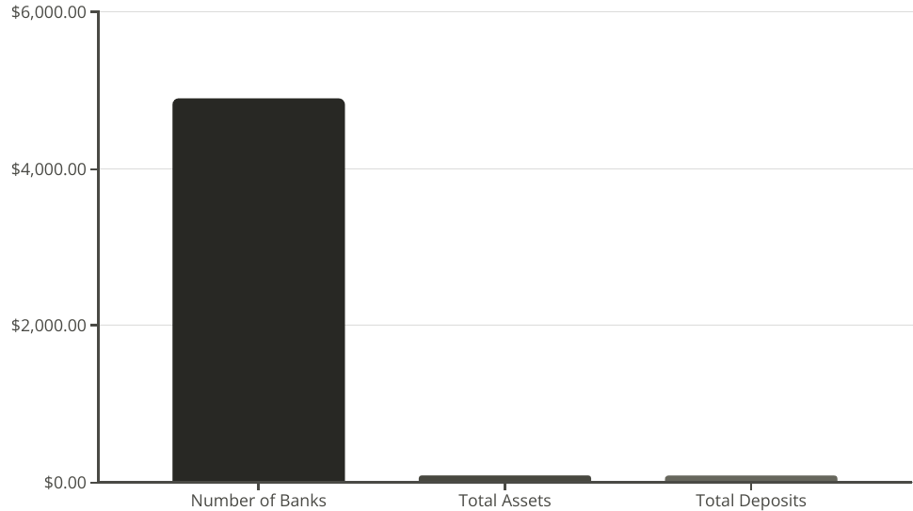

**Graphical Representation: Market Share of Top Banks**

**Branch Network Mapping**

Visualizing the geographic distribution of bank branches provides valuable insights into market coverage, customer accessibility, and competitive positioning. By mapping the locations of physical branches, banks can identify underserved areas, optimize branch networks, and make strategic decisions about future expansion or consolidation.

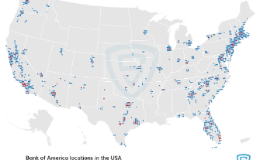

**Market Dominance of Top Banks**

The US banking industry is highly concentrated, with the top five banks accounting for over 50% of total banking assets. JPMorgan Chase, Bank of America, Wells Fargo, Citigroup, and U.S. Bank have established themselves as the industry leaders, leveraging their extensive branch networks, diverse product offerings, and strong brand recognition to capture a significant share of the market.

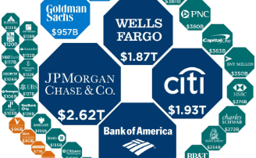

**Deposits and Market Share**

In terms of deposits, the top banks also maintain a dominant position. JPMorgan Chase, Bank of America, and Wells Fargo collectively hold nearly 40% of all deposits in the US banking system. This concentration of deposits provides these banks with a significant advantage in terms of funding and liquidity, allowing them to offer more competitive lending rates and a wider range of financial services to their customers.

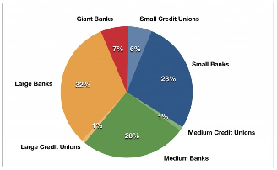

**Loan Portfolio Dominance**

The top banks also hold a significant share of the loan market, with the top five institutions accounting for over 60% of total loans. This market share translates into greater pricing power, enabling these banks to generate higher net interest margins and profitability. The sheer size and scale of the top banks allow them to leverage their resources and expertise to serve a diverse range of borrowers, from individuals to large corporations.

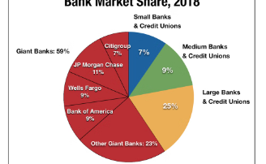

**Customer Demographic Analysis**

Analyzing customer demographics through graphical representations can help banks better understand their target market, tailor product offerings, and develop effective marketing strategies. Charts and graphs depicting age, income, geographic distribution, and other key customer characteristics enable banks to make data-driven decisions and deliver personalized services.

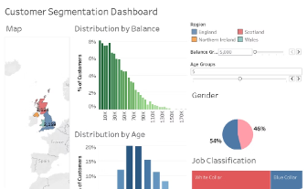

**Financial Performance Tracking**

Tracking the financial performance of banks over time through visually compelling graphs and charts is crucial for monitoring key metrics, identifying trends, and guiding strategic decisions. Visualizations of metrics such as asset growth, profitability, and market share can help banks identify opportunities, address challenges, and communicate their performance to stakeholders.

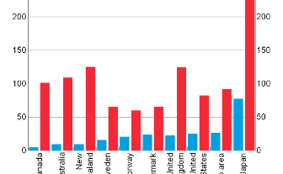

**Predictive Analytics: Trends in Bank Consolidation**

The US banking industry has seen a steady trend of consolidation, with the number of banks declining significantly over the past decades. Predictive analytics suggest this trend will continue, driven by technological advancements, changing customer preferences, and regulatory pressures. Smaller banks, struggling to keep up with investments in cybersecurity, digital platforms, and compliance, are increasingly merging with larger institutions. Customers are also gravitating towards larger, diversified banks that offer a wide range of products and services.

**Prescriptive Analytics: Regulatory Implications and Recommendations**

As the US banking sector evolves, regulatory bodies must adapt to ensure the industry remains stable, competitive, and consumer-friendly. Based on predictive trends, several recommendations emerge:

**Enhanced Capital Requirements**: Increase capital reserve ratios for the largest banks to mitigate systemic risks.

**Stricter Merger and Acquisition Oversight**: Make the approval process for bank mergers more rigorous to ensure fair competition and consumer choice.

**Promoting Community Bank Resilience**: Introduce programs and incentives to support smaller, community-based banks, ensuring they continue to serve local economies.

Balancing these regulatory actions can foster a more stable, diverse, and competitive banking landscape, serving all stakeholders from individual consumers to large enterprises.

**Numerical Data: Projected Changes in Bank Concentration**

As the US banking industry continues to evolve, analysts have developed detailed projections on the expected changes in bank concentration over the coming years. Recent studies indicate that the trend towards consolidation and the dominance of a few large players is likely to continue.

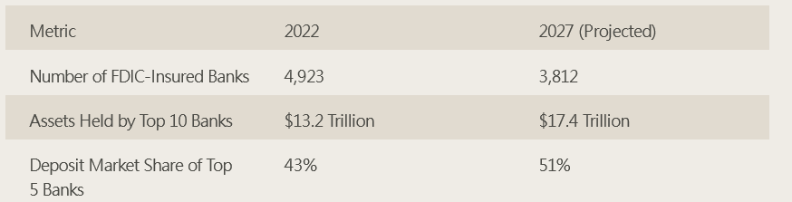

The trend towards consolidation in the US banking industry is expected to continue. Analysts project that the number of FDIC-insured banks will decrease by over 20% in the next five years, with smaller players being acquired or exiting the industry. Meanwhile, the top banks will continue to grow their asset base and capture a greater share of deposits, raising concerns about systemic risk and financial power concentration

**Graphical Representation: Forecast of Industry Dynamics**

Our forecast model indicates further consolidation over the next decade, leading to a more concentrated market. The largest institutions are expected to expand their dominance, while smaller and regional banks may struggle to keep pace. This will result in an oligopolistic structure, with fewer banks controlling a larger portion of assets and deposits.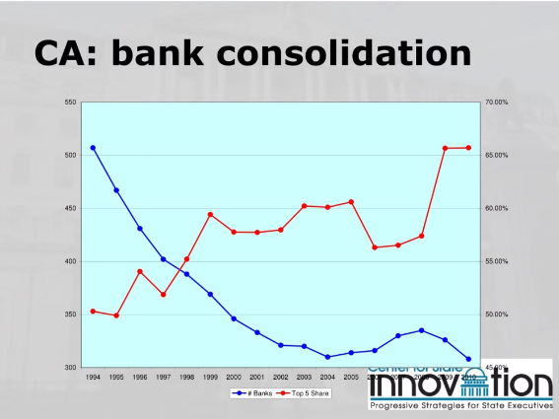

**Challenges and Opportunities in the US Banking Landscape**

The US banking sector faces numerous challenges, including continued consolidation, fintech disruption, and regulatory compliance. However, these challenges also present opportunities for innovation. Advancements in data analytics and AI can enable banks to offer more personalized services, while investments in sustainable financing and ESG initiatives can position the industry as a leader in addressing global challenges

**Conclusion and Key Takeaways**

Our analysis of the US banking structure highlights the diverse composition of the sector, the concentration of assets and deposits among the largest banks, and the ongoing trend of consolidation. Predictive analytics suggest this trend will continue, driven by technological and regulatory factors. Prescriptive recommendations emphasize the need for balanced regulatory approaches to foster innovation, stability, and community banking resilience.Key takeaways include the concentration of assets and deposits among the largest banks, the potential risks of further consolidation, and the importance of maintaining a diverse banking ecosystem. Ongoing vigilance and strategic decision-making will be crucial in shaping the future of the US banking landscape.

**Data Sources:**

Federal Deposit Insurance Corporation (FDIC): <https://banks.data.fdic.gov/bankfind-suite>

Federal Reserve Board (FRB): <https://fred.stlouisfed.org/source?soid=1>

SIFMA Research: <https://www.sifma.org/resources/research/research-quarterly-us-financial-institutions/>